**E Book management system**

Use case diagram:

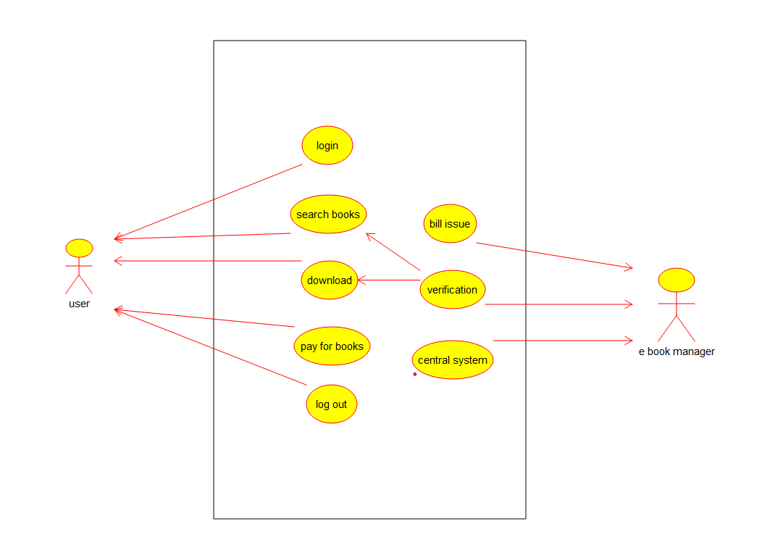

Object diagram:

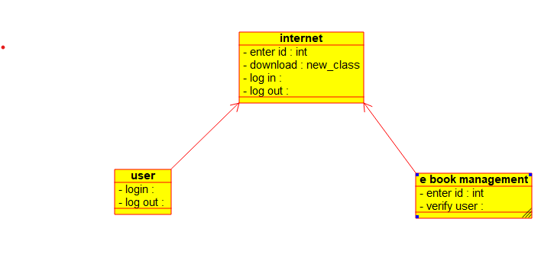

Component diagram:

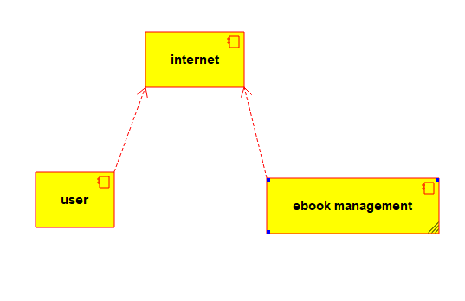

Sequence diagram:

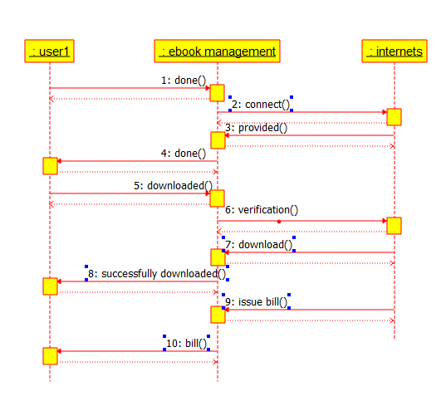

Collaboration diagram:

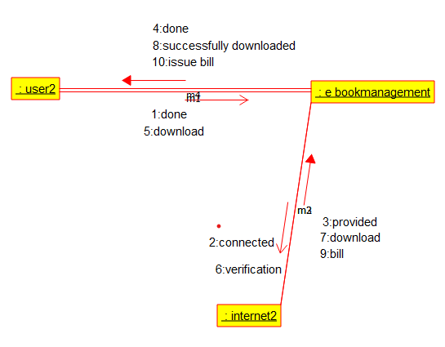

Deployment diagram:

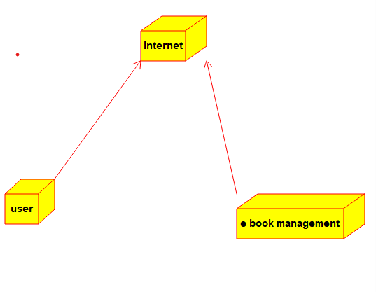

Program:

Internet:

/**

* Class e_book_management

*/

public class e_book_management {

//

// Fields

//

private int enter_id;

private void verify_user;

//

// Constructors

//

public e_book_management () { };

//

// Methods

//

//

// Accessor methods

//

/**

* Set the value of enter_id

* @param newVar the new value of enter_id

*/

public void setEnter_id (int newVar) {

enter_id = newVar;

}

/**

* Get the value of enter_id

* @return the value of enter_id

*/

public int getEnter_id () {

return enter_id;

}

/**

* Set the value of verify_user

* @param newVar the new value of verify_user

*/

public void setVerify_user (void newVar) {

verify_user = newVar;

}

/**

* Get the value of verify_user

* @return the value of verify_user

*/

public void getVerify_user () {

return verify_user;

}

//

// Other methods

//

/**

*/

public void check_availability()

{

}

}

/**

* Class internet

*/

public class internet {

//

// Fields

//

private int enter_id;

private new_class download;

private void log_in;

private void log_out;

//

// Constructors

//

public internet () { };

//

// Methods

//

//

// Accessor methods

//

/**

* Set the value of enter_id

* @param newVar the new value of enter_id

*/

public void setEnter_id (int newVar) {

enter_id = newVar;

}

/**

* Get the value of enter_id

* @return the value of enter_id

*/

public int getEnter_id () {

return enter_id;

}

/**

* Set the value of download

* @param newVar the new value of download

*/

public void setDownload (new_class newVar) {

download = newVar;

}

/**

* Get the value of download

* @return the value of download

*/

public new_class getDownload () {

return download;

}

/**

* Set the value of log_in

* @param newVar the new value of log_in

*/

public void setLog_in (void newVar) {

log_in = newVar;

}

/**

* Get the value of log_in

* @return the value of log_in

*/

public void getLog_in () {

return log_in;

}

/**

* Set the value of log_out

* @param newVar the new value of log_out

*/

public void setLog_out (void newVar) {

log_out = newVar;

}

/**

* Get the value of log_out

* @return the value of log_out

*/

public void getLog_out () {

return log_out;

}

//

// Other methods

//

/**

*/

public void verify()

{

}

/**

*/

public void status()

{

}

}

E book:

/**

* Class e_book_management

*/

public class e_book_management {

//

// Fields

//

private int enter_id;

private void verify_user;

//

// Constructors

//

public e_book_management () { };

//

// Methods

//

//

// Accessor methods

//

/**

* Set the value of enter_id

* @param newVar the new value of enter_id

*/

public void setEnter_id (int newVar) {

enter_id = newVar;

}

/**

* Get the value of enter_id

* @return the value of enter_id

*/

public int getEnter_id () {

return enter_id;

}

/**

* Set the value of verify_user

* @param newVar the new value of verify_user

*/

public void setVerify_user (void newVar) {

verify_user = newVar;

}

/**

* Get the value of verify_user

* @return the value of verify_user

*/

public void getVerify_user () {

return verify_user;

}

//

// Other methods

//

/**

*/

public void check_availability()

{

}

}

User:

/**

* Class e_book_management

*/

public class e_book_management {

//

// Fields

//

private int enter_id;

private void verify_user;

//

// Constructors

//

public e_book_management () { };

//

// Methods

//

//

// Accessor methods

//

/**

* Set the value of enter_id

* @param newVar the new value of enter_id

*/

public void setEnter_id (int newVar) {

enter_id = newVar;

}

/**

* Get the value of enter_id

* @return the value of enter_id

*/

public int getEnter_id () {

return enter_id;

}

/**

* Set the value of verify_user

* @param newVar the new value of verify_user

*/

public void setVerify_user (void newVar) {

verify_user = newVar;

}

/**

* Get the value of verify_user

* @return the value of verify_user

*/

public void getVerify_user () {

return verify_user;

}

//

// Other methods

//

/**

*/

public void check_availability()

{

}

}

/**

* Class user

*/

public class user {

//

// Fields

//

private void login;

private void log_out;

//

// Constructors

//

public user () { };

//

// Methods

//

//

// Accessor methods

//

/**

* Set the value of login

* @param newVar the new value of login

*/

public void setLogin (void newVar) {

login = newVar;

}

/**

* Get the value of login

* @return the value of login

*/

public void getLogin () {

return login;

}

/**

* Set the value of log_out

* @param newVar the new value of log_out

*/

public void setLog_out (void newVar) {

log_out = newVar;

}

/**

* Get the value of log_out

* @return the value of log_out

*/

public void getLog_out () {

return log_out;

}

//

// Other methods

//

/**

*/

public void surf_books()

{

}

}